Project Planning Phase
Project Planning Template (Product Backlog, Sprint Planning, Stories, Story points)

Date | 18 October 2022
Team ID | PNT2022TMID37290
Project Name | Machine learning based car performance analyzer.
Maximum Marks | 8 Marks

Product Backlog, Sprint Schedule, and Estimation (4 Marks)
Use the below template to create product backlog and sprint schedule
Sprint | Functional Requirement (Epic) | User Story Number | User Story / Task | Story Points | Priority | Team Members
Sprint-1 | Data pre-processing | USN-1 | Pre-processing of the dataset. | 5 | High | Nishanth R  Sai Abhishek M  Naman Mehta  Diyanesh Rohan
Sprint-2 | Model Building for prediction | USN-5 | Building model for accurate performance prediction | 10 | High | Nishanth R  Sai Abhishek M  Naman Mehta  Diyanesh Rohan
Sprint-3 | Integrate the model with Flask | USN-6 | The model needs to be integrated with front - end | 20 | High | Nishanth R  Sai Abhishek M  Naman Mehta  Diyanesh Rohan
Sprint-4 | Result | USN-7 | The final result of the prediction. | 20 | High | Nishanth R  Sai Abhishek M  Naman Mehta  Diyanesh Rohan

Project Tracker, Velocity & Burndown Chart: (4 Marks)
Sprint | Total Story Points | Duration | Sprint Start Date | Sprint End Date (Planned) | Story Points Completed (as on Planned End Date) | Sprint Release Date (Actual)
Sprint-1 | 20 | 6 Days | 24 Oct 2022 | 29 Oct 2022 | 20 | 29 Oct 2022
Sprint-2 | 20 | 6 Days | 31 Oct 2022 | 05 Nov 2022
Sprint-3 | 20 | 6 Days | 07 Nov 2022 | 12 Nov 2022
Sprint-4 | 20 | 6 Days | 14 Nov 2022 | 19 Nov 2022

Velocity:
Imagine we have a 10-day sprint duration, and the velocity of the team is 20 (points per sprint). Let’s calculate the team’s average velocity (AV) per iteration unit (story points per day)
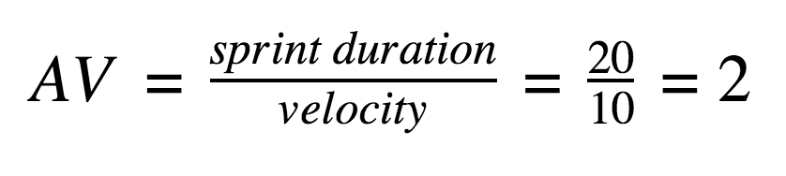

Burndown Chart:
A burn down chart is a graphical representation of work left to do versus time. It is often used in agile software development methodologies such as Scrum. However, burn down charts can be applied to any project containing measurable progress over time.

https://www.visual-paradigm.com/scrum/scrum-burndown-chart/
https://www.atlassian.com/agile/tutorials/burndown-charts

Reference:
https://www.atlassian.com/agile/project-management
https://www.atlassian.com/agile/tutorials/how-to-do-scrum-with-jira-software
https://www.atlassian.com/agile/tutorials/epics
https://www.atlassian.com/agile/tutorials/sprints
https://www.atlassian.com/agile/project-management/estimation
https://www.atlassian.com/agile/tutorials/burndown-charts

